Polynomial and Rational Functions Name _________________________
A2RCC U8D1 Homework

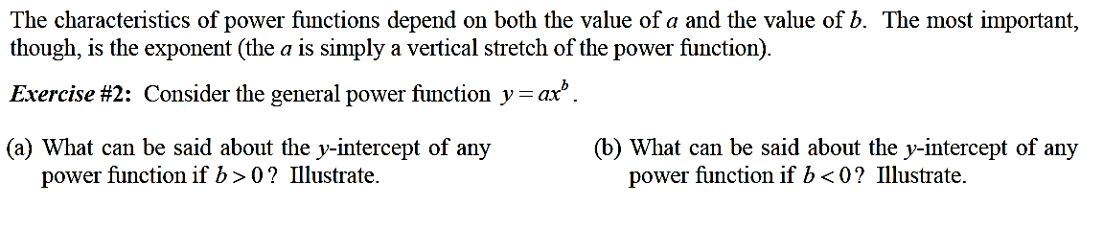

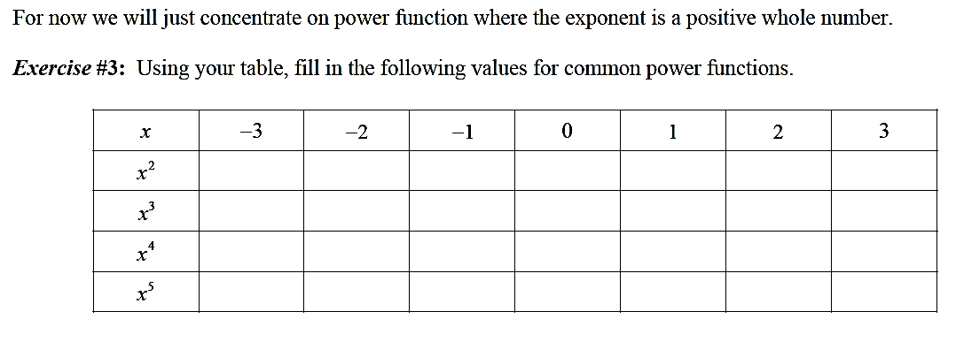

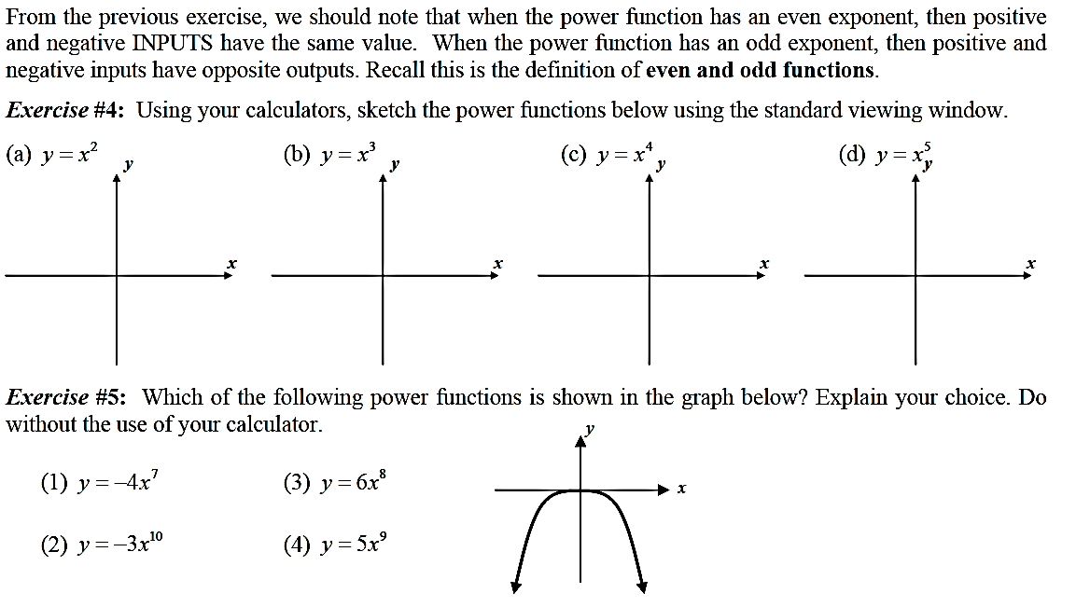

- For each polynomial, give a power function that best represents the end behavior of the polynomial. Describe (sketch) the end behavior for each.

- $f(x)=x^{3}+10x^{2}+32x+34$ | - $f\left(x\right)=-x^{2}-8x-15$ | - $f\left(x\right)=-x^{4}+x^{2}+2$
- $f(x)=3x^{4}-4x^{2}-x+3$ | - $f(x)=-5x^{3}+2x^{2}+2$ | - $f(x)=4x^{4}-x^{2}-2$
- $f(x)=x^{3}-3x^{2}+1$ | - $f(x)=3x^{5}-4x^{3}+x+1$ | - $f\left(x\right)=-7x^{5}+4x^{3}-5x-4$

